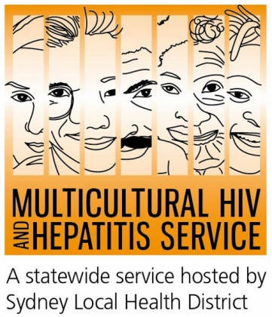

Media Release
1st July 2017
Hep B: Could it be me? campaign series launched
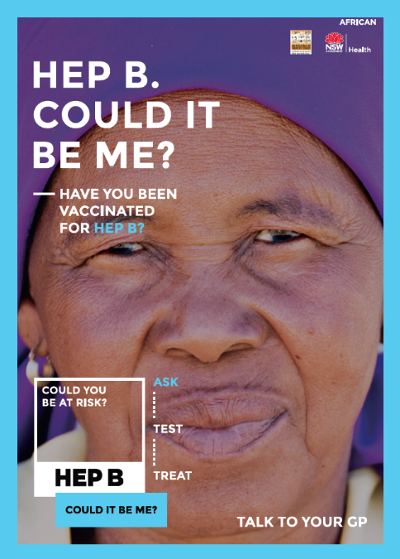
The Multicultural HIV and Hepatitis Service has today announced the launch of the “Hep B: Could it be me?” campaign series in NSW. Aimed at increasing awareness of hepatitis B in diverse communities, the campaign encourages people to ASK, TEST and TREAT hepatitis B.
Nearly a month ahead of World Hepatitis Day on 28 July, the campaign is aimed at raising the profile of hepatitis B in the community, according to the founding president of the African Women’s Association in NSW, Rosemary Kariyuki-Fyfe.
“Hepatitis B is common in many culturally diverse communities, including our own. Most people with hepatitis B don’t have symptoms and many don’t know they have it. Through this campaign, we hope to raise its awareness and put it firmly on our community’s agenda," Ms Kariyuki-Fyfe said.
There are more than 239,000 people living with chronic hepatitis B in Australia with about 84,000 in NSW. Nearly 40 per cent of them don’t know they have the virus. Untreated, chronic hepatitis B can cause serious liver damage and liver cancer.
The campaign encourages people to ask if they are at risk of hepatitis B, according to Gai Stackpool, the Acting Manager of the Multicultural HIV and Hepatitis Service (MHAHS).
“The slogan Hep B: Could it be me? encourages people to ask their doctor if they are at risk of having chronic hepatitis B and to ask for a test. The sooner you're diagnosed, the quicker you can access treatment. Treatments are highly effective. They reduce damage to the liver and reduce the risk of liver cancer,” Ms Stackpool said.
Ms Kariyuki-Fyfe released important points that members of the African community in Australia can use to tackle hepatitis B:
- It is important to ask your doctor if you are at risk of having chronic hepatitis B.
- The only way to know if you have chronic hepatits B is by having a blood TEST. ASK your doctor for a hepatitis B test.
- Hepatitis B is common in our communities. Most people with hepatitis B don’t have symptoms and many don’t know they have it.
- There are treatments that can control the hepatitis B virus and reduce damage to your liver and reduce the risk of liver cancer.
- ASK. TEST. TREAT hepatitis B.
The Hep B: Could it be me? campaign series is supported by a number of hepatitis B forums organised by the MHAHS in partnership with key community organisations. As well as distributing a number of resources such as posters, magnets and stickers, the campaign is promoting hepatitis testing, treatment and prevention messages through key community publications and radio stations.
For more details about Hep B: Could it be me? ASK,TEST and TREAT visit www.hepb.org.au
Talk to your doctor about hepatitis B and ask for a test. In Australia, all conversations with your doctor remain private. Or call the Hepatitis Hotline on 1800 803 990. If you want to use a telephone interpreter, first call 131 450.
For further information or to arrange a radio nterview, please contact Sonam Paljor at the MHAHS on 02-9515 1234.

