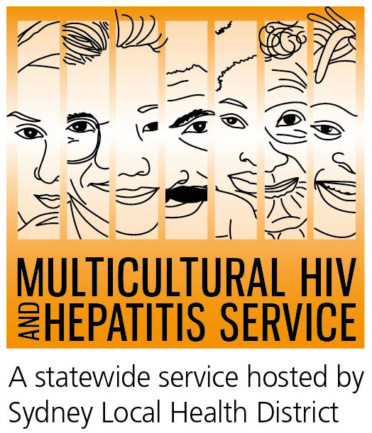

Media Release
28 July 2016
World Hepatitis Day 2016:
Diverse communities urged not to miss out on life saving liver treatment

Thousands of people stand to be cured of viral hepatitis if they speak to their doctors, according to this year’s World Hepatitis Day campaign. The day, on July 28, aims to increase awareness of viral hepatitis treatment with the #NoHep campaign promoting testing and treatment as keys to eliminating viral hepatitis by 2030.

Finding out if you have hepatitis B or C can enable you to access new viral hepatitis treatments, according to Barbara Luisi, manager of the Multicultural HIV and Hepatitis Service (MHAHS).

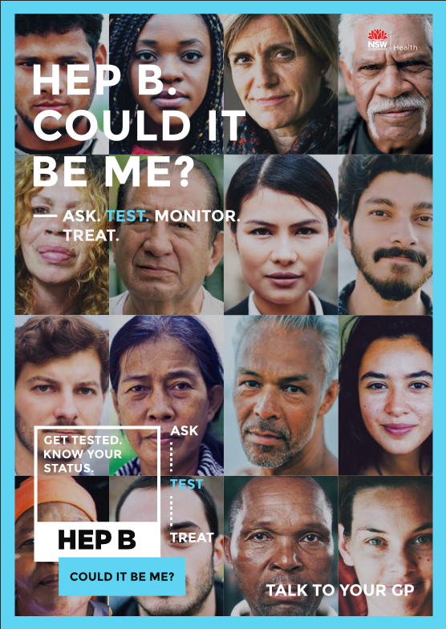
“Many people from culturally diverse backgrounds still do not know there are new treatments available for viral hepatitis. If you know you have viral hepatitis or think you have been exposed to viral hepatitis, then talking to your doctor about it can ensure that you get treatment on time. This can prevent liver cancer and even save your life,” said Ms Luisi.

“Hepatitis B and hepatitis C viruses claim the lives of 1000 Australians a year – but the good news is we can now prevent liver damage and death, as well as improve the day-to-day lives of thousands of people, but only if more people come forward to get tested and receive treatment.
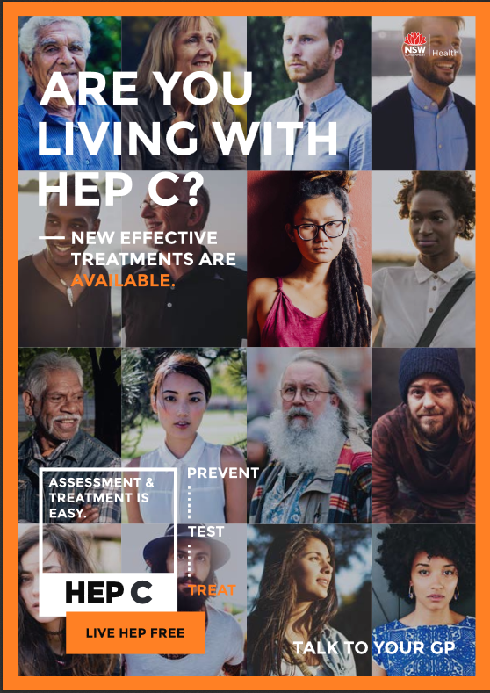
“Simple actions such as being tested for the virus or having a regular liver check-up can quite literally save lives by ensuring that treatment starts at the right time, she said.

Despite more than 230,000 Australians living with chronic hepatitis C and a further 213,000 living with chronic hepatitis B, not enough people living with these conditions receive treatment.

Dr Simone Strasser, Senior Staff Specialist at the Australian National Liver Transplant Unit at Royal Prince Alfred Hospital said that in the last year there had been a dramatic improvement in the treatments available for hepatitis C. These new antiviral medicines are much more effective and have far fewer side-effects than previous treatments.

“Thousands of people have already benefited from new therapies that cure the hepatitis C virus,” she said.

“Recent treatment advances for hepatitis C, vaccination for hepatitis B, and the development of fast and painless liver scans to monitor liver health, mean that we can manage and treat both hepatitis B and hepatitis C before serious liver disease develops.

“World Hepatitis Day provides an important reminder for families and communities to talk about viral hepatitis and make sure we turn the tide on these two conditions.

Dr Strasser released a list of actions that members of the Khmer community in Australia can take to tackle viral hepatitis:
- Acknowledge that viral hepatitis is very common in our community and can cause cancer if left untreated.
- Ask your doctor about being tested for hepatitis B and C. There are treatments that can prevent liver cancer.
- If you’re living with viral hepatitis, see your doctor for regular liver check-ups.
- If you are living with hepatitis C, talk to your doctor about new treatment options that can cure nine-in-ten people in as little as 12 weeks.

“Every Australian has a role to play in the fight against viral hepatitis. We should take courage from knowing that we have the tools to test, treat and prevent viral hepatitis and make this condition rare in our lifetime. Let’s make it happen,” said Dr Strasser.

Hepatitis Awareness Week is coordinated by Hepatitis Australia – which has launched several resources including a poster titled #NoHep emphasising regular liver testing and treatment.

Visit www.mhahs.org.au for more information on viral hepatitis and resources related to the World Hepatitis Day and Hepatitis Awareness Week.

Talk to your doctor about hepatitis B and C (in Australia, all conversations with your doctor remains private) or call the Hepatitis Hotline on 1800 803 990. If you want to use a telephone interpreter, first call 131 450.

Ends#

For further information or to arrange an interview in Khmer, please contact Sonam Paljor at the MHAHS on 02-9515 1234.

For more information, visit www.worldhepatitisday.org.au

