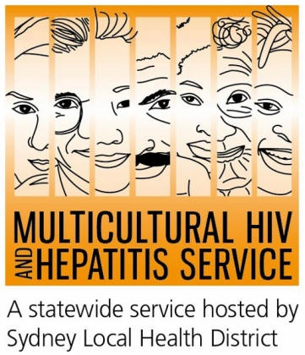

New campaign advances hepatitis B treatment
The Multicultural HIV and Hepatitis Service has launched a new campaign to highlight the benefits of hepatitis B treatment in culturally diverse communities in NSW. Launched as part of the Hep B: Could it be me? series, the campaign highlights how hepatitis B treatment can prevent liver cancer.
The new campaign reassures people about how hepatitis B treatment could prevent liver disease and save lives,” according to Alice Lea*, a person from culturally diverse background living with hepatitis B.
“Once you are diagnosed with chronic hepatitis B, the virus is likely stay in your blood and liver for your lifetime. But there are effective medical treatments that can control the hepatitis B virus and help reduce the risk of developing serious liver disease and cancer. The most important thing to remember is that hepatitis B can be successfully managed if you take good care of your health and your liver. You should expect to live a long, full life,” said Ms Lea.
The campaign seeks to correct prevailing community perceptions about hepatitis B treatment.
“Some people think hepatitis B will never cause a problem because they know many people have it who don’t have any health problems. Other people might feel the complete opposite and think that they cannot do anything about it because they have seen their close friends and relatives die from it. The campaign highlights how treatment and care can help people lead full and healthy lives,” said Ms Lea.
There are more than 238,000 people living with hepatitis B in Australia with about 84,000 in NSW. Hepatitis B viruses claim about 1000 Australian lives a year.
Thousands of people stand to benefit from hepatitis B treatment if they know their hepatitis B status, according to Lucy Mukoko, Shona-speaking Health Education Officer at the MHAHS.
“Many people from culturally diverse backgrounds still do not know if they have the virus nor the availability of effective hepatitis B treatments. The campaign encourages people to ask their doctor if they are at risk of having chronic hepatitis B and ask for a test. The campaign is also encouraging people already diagnosed with chronic hepatitis B to ask their doctor if they need to be on hepatitis B treatment. Starting hepatitis B treatment early helps improve daily life, work and relationships,” Ms Mukoko said.
Some of the key hepatitis B messages are:
- It is important to ask your doctor if you are at risk of having chronic hepatitis B.
- The only way to know if you have chronic hepatits B is by having a blood TEST. ASK your doctor for a hepatitis B test.
- Hepatitis B is common in our communities. Most people with hepatitis B don’t have symptoms and many don’t know they have it.
- There are treatments that can control the hepatitis B virus and reduce damage to your liver and reduce the risk of liver cancer.
- ASK. TEST. TREAT hepatitis B.
For more information about hepatitis B testing and treatments, including a list of doctors specifically trained in the care and management of people living with hepatitis B can be viewed here.<Link>
The Hep B: Could it be me? campaign series is supported by a number of hepatitis B forums organised by the MHAHS in partnership with key community organisations. As well as distributing a number of resources such as posters, magnets and stickers, the campaign is promoting hepatitis testing, treatment and prevention messages through key community publications and radio stations.
Talk to your doctor about hepatitis B and ask for a test. In Australia, all conversations with your doctor remains private. Or call the Hepatitis Hotline on 1800 803 990. If you want to use a telephone interpreter, first call 131 450.
For further information or to arrange an interview, please contact Sonam Paljor at the MHAHS on 02-9515 1234.

- * Name altered to protect privacy

