
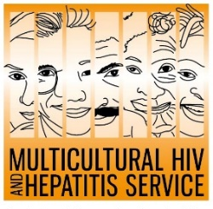
Media Release
15th of October 2020

Taking care of your health – and your liver in the COVID-19 era
As the COVID-19 pandemic increases people’s awareness of their health and wellbeing, the Multicultural HIV and Hepatitis Service (MHAHS) is reminding people of the necessity to take care of their health and their liver in a state-wide multi-channel hepatitis B campaign.
The campaign encourages people from diverse communities to get tested for hepatitis B. The aim is to raise awareness of hepatitis B testing and treatment in Arabic, Chinese, Korean and Vietnamese-speaking communities living in NSW.
Beginning 19 October, the month-long campaign will run across ethnic newspaper, radio and social media outlets, and communicate a simple message: Are you living with hepatitis B? Find Out. Get Tested.
Getting check-ups and finding whether you are living with hepatitis B matters even more during COVID-19, according to Barbara Luisi, Director of Diversity Programs and Strategy Hub.
“The spread of the coronavirus reminds us of the importance of taking care of ourselves,” said Ms Luisi.
“There are many things we can do to take care of ourselves, including maintaining a healthy lifestyle, doing regular check-ups and being aware of any potential health issues before it is too late. Getting tested and finding whether you have hepatitis B is part of it.”
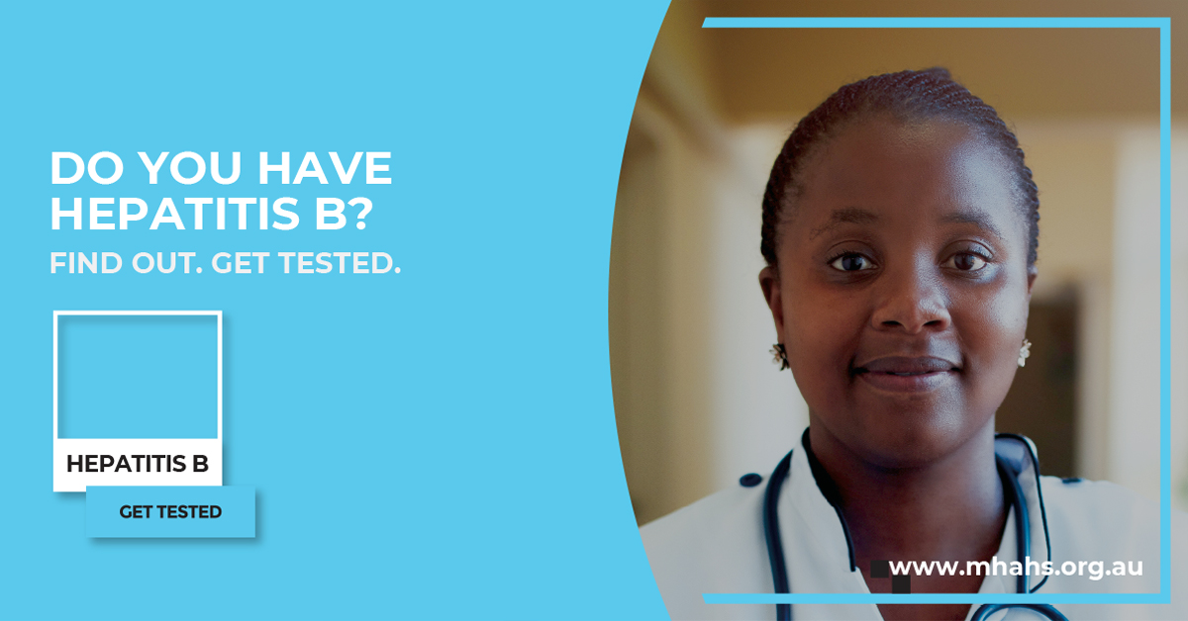
An estimated 325 million people are living with viral hepatitis in the world with nearly 90% of them unaware that they are infected, according to the World Health Organization. Without treatment, it can lead to liver cancer.
In Australia, there were an estimated 230,034 people living with chronic hepatitis B as of the end of 2016, according to a report published by the Kirby Institute in 2019, with only 7% were receiving treatment. A large proportion of people living with chronic hepatitis B is still undiagnosed, many of them are born overseas.
Effective treatments are available which improve the health of people living with chronic hepatitis B. Early access to treatment prevents serious liver damage and allows people to live longer, healthier lives.
The campaign encourages people to speak to their doctor and families about getting a hepatitis B test.
Four key messages are conveyed through the campaign to tackle hepatitis B among diverse communities:
- People from diverse communities should talk to their doctor and ask for a hepatitis B test. All conversations with your doctor remain private in Australia.
- The only way to know if you have chronic hepatitis B is by having a specific blood test.
- Hepatitis B is common in many diverse communities, although most people with hepatitis B remain unaware and do not have any symptoms.
- Effective treatments are available that control the hepatitis B virus and reduce liver damage and the risk of liver cancer.
A multilingual resource toolkit, which includes the campaign resources and guidelines for use is available on the campaign webpage.
For media interviews, please call Sonam Paljor at 95151234 or email sonam.paljor@health.nsw.gov.au

