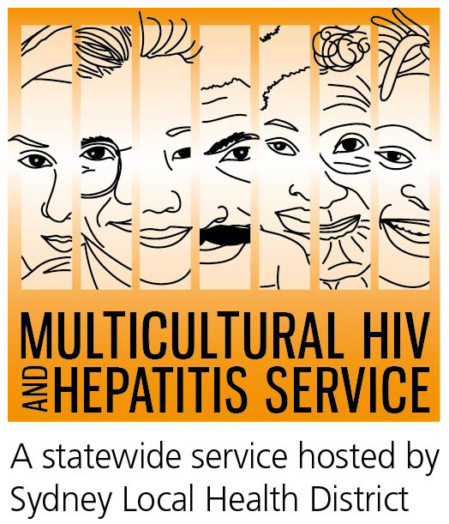

Media Release
27th November 2015
2015 World AIDS Day campaign/HIV Awareness Week:
More HIV tests key to timely diagnosis
Offering more HIV tests, more often are keys to ensuring HIV is diagnosed on time, according to this year’s World AIDS Day/HIV Awareness Week campaign. Titled Test Often, Treat Early, the campaign (November 24 – November 30) seeks to encourage more people to get tested and seek treatment on time. The national slogan Getting to Zero, highlights our commitment to keep fighting for the wellbeing of all the people who live everyday with HIV.
Late HIV diagnosis is an important health issue among people from culturally and linguistically diverse (CALD) backgrounds, according to Barbara Luisi, Manager of the MHAHS (Multicultural HIV and Hepatitis Service).
“People miss out on receiving HIV treatment on time if they are diagnosed late. They miss out on making informed decisions around sex and health care to protect their wellbeing. They are also more likely to develop serious, life-threatening conditions than those diagnosed earlier. Nationally, in 2014, more than 30 per cent of new diagnoses in people from CALD backgrounds were “late” with those from South East Asia and sub Saharan Africa among the most affected,” said Ms Luisi.
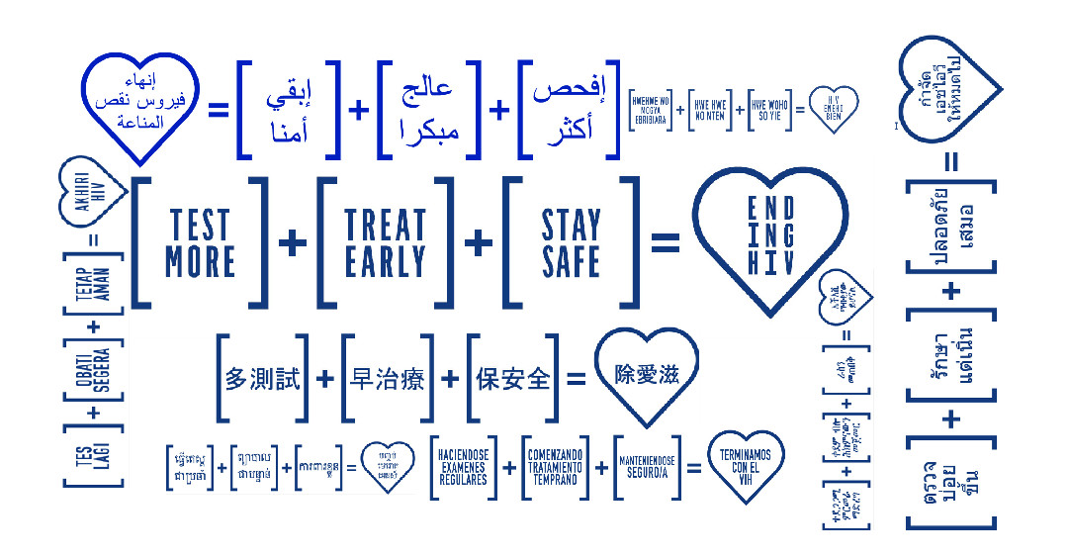
“One of the aims of this campaign is to lower the number of people whose HIV is discovered late. Often people get tested late because they may be scared, but also because they have no idea they may have HIV. Better access to testing by routinely offering testing across a variety of health services could reach such people,” said Ms Luisi.
Fear of HIV stigma is one of the most common barriers to seeking an HIV test, according to the Clinical Supervisor, Dash Gray.
“There is secrecy and silence around HIV, because HIV transmission is associated with stigmatised behaviour such as promiscuity and infidelity. HIV is a difficult topic to discuss. As well as the fear of being diagnosed HIV positive, people also worry about confidentiality. Therefore, the stigma of HIV transmission is then transferred to HIV testing,” said Ms Gray.
Artist and activist, Justin Xiao, 22, who faced discrimination as a result of his HIV status agrees. He identifies stigma as one of the key challenges behind increasing HIV testing.
“There is a real social stigma behind the HIV label. Some people see you as a threat to their personal life and that’s really painful. Stigma discourages you from getting tested," said Mr Xiao.
Language barriers, lack of knowledge about the health care system and fear of disclosure of their HIV status are some of the factors that stop widespread HIV testing among CALD communities.
Ms Luisi says “raising awareness of the benefits of testing and working with the whole community including people living with HIV is core to reducing HIV stigma.
World AIDS Day is an opportunity to address the HIV-related stigma that still persists in Australia, undermining prevention, testing and treatment efforts and causing social isolation for many people living with HIV.
Numerous events are organised across Australia to support the HIV awareness campaign. The Sydney Local Health District based MHAHS is undertaking several initiatives during the campaign. As well as promoting the Ending HIV equation across ten communities, it is partnering with South Eastern Sydney Local Health District to organise a free HIV forum for health and community workers providing services to people from CALD backgrounds. Register here.
HIV is most commonly transmitted through unprotected sexual contact. Condoms are one of the most effective ways to prevent the transmission of HIV.
There is currently no cure or vaccine available for HIV/AIDS. However, there are effective treatments that can greatly slow the effect HIV has on the body, and means that people with HIV can live long, healthy and productive lives.
For further information on free and anonymous HIV testing, please contact your local sexual health clinic, listed under Sexual in the White Pages.
To contact a service using a telephone interpreter, call 131 450 from anywhere in Australia for the cost of a local call. Discussions through an interpreter are always confidential.
Some of the major sexual health clinics in Australia include:
NSW: Sydney (02) 9382 7440 / Liverpool (02) 9827 8022
VIC: Melbourne (03) 9347 0244
SA: Adelaide (08) 8226 6025
QLD: Brisbane (07) 3227 8666
--- END ---
For media interviews, please call 9515 1241.
About Ending HIV equation:
The multilingual "Ending HIV" campaign promotes three steps to eliminate the spread of HIV by 2020:
Test More - more people need to get tested more often, as this is the only way that undiagnosed infections can be decreased and treatment can be increased.
Free and anonymous HIV tests are available at sexual health clinics located across Australia. At sexual health clinics you do not need to have a Medicare card or give your real name.
Treat Early - advances in HIV medicines offer better health benefits for people with HIV and can reduce traces of the virus in their body to an undetectable level. This reduces the likelihood of transmitting HIV significantly.
Stay Safe - condoms and other risk reduction strategies remain central to the fight against HIV so people need to maintain a culture of safe sex
About HIV/AIDS
AIDS is a disease caused by a virus known as HIV and affects men, women and children from all cultures, countries and religions.
According to the Joint United Nations’ Program on HIV/AIDS (UNAIDS), there were more than estimated 36 million people living with HIV at the end of 2014. In Australia, there were more than 23 thousand people living with diagnosed HIV infection in 2014. People from CALD backgrounds represented 40 per cent of new diagnoses in Australia in 2013.
Late HIV diagnosis
Late HIV diagnosis was defined as newly diagnosed HIV infection with a CD4+ cell count of less than 350 cells/μl, and advanced HIV infection as newly diagnosed infection with a CD4+ cell count of less than 200 cells/μl. Newly acquired cases excluded from late or advanced categorisation.
About the MHAHS (Multicultural HIV and Hepatitis Service)
The Multicultural HIV and Hepatitis Service, hosted by the Sydney Local Health District, employs workers from more than 20 language backgrounds, including Asian and African languages, who provide support to people affected by HIV in NSW. The workers are bound by strict laws protecting the privacy of the people they support. The service is free and no identification of any kind is needed. It can be reached on (02) 9515 1234

