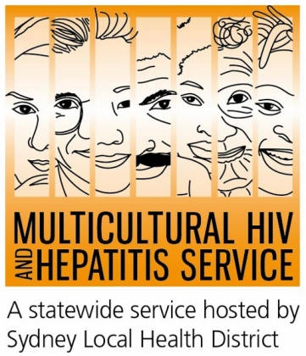
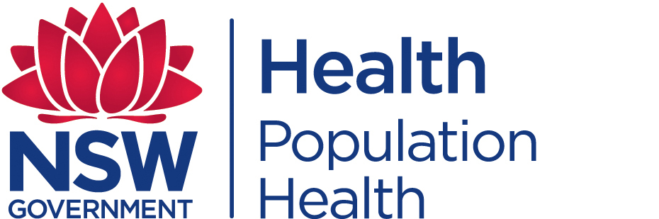
Media Release
30 November 2016
Free HIV home test launched to increase HIV testing
The NSW Ministry of Health has launched the first state-wide HIV home testing kit for those at higher-risk of HIV infection.
People at higher-risk of HIV across NSW can now order a free home testing kit online and are encouraged to do a simple finger-prick blood sample for HIV Awareness Week starting on 21 November 2016.
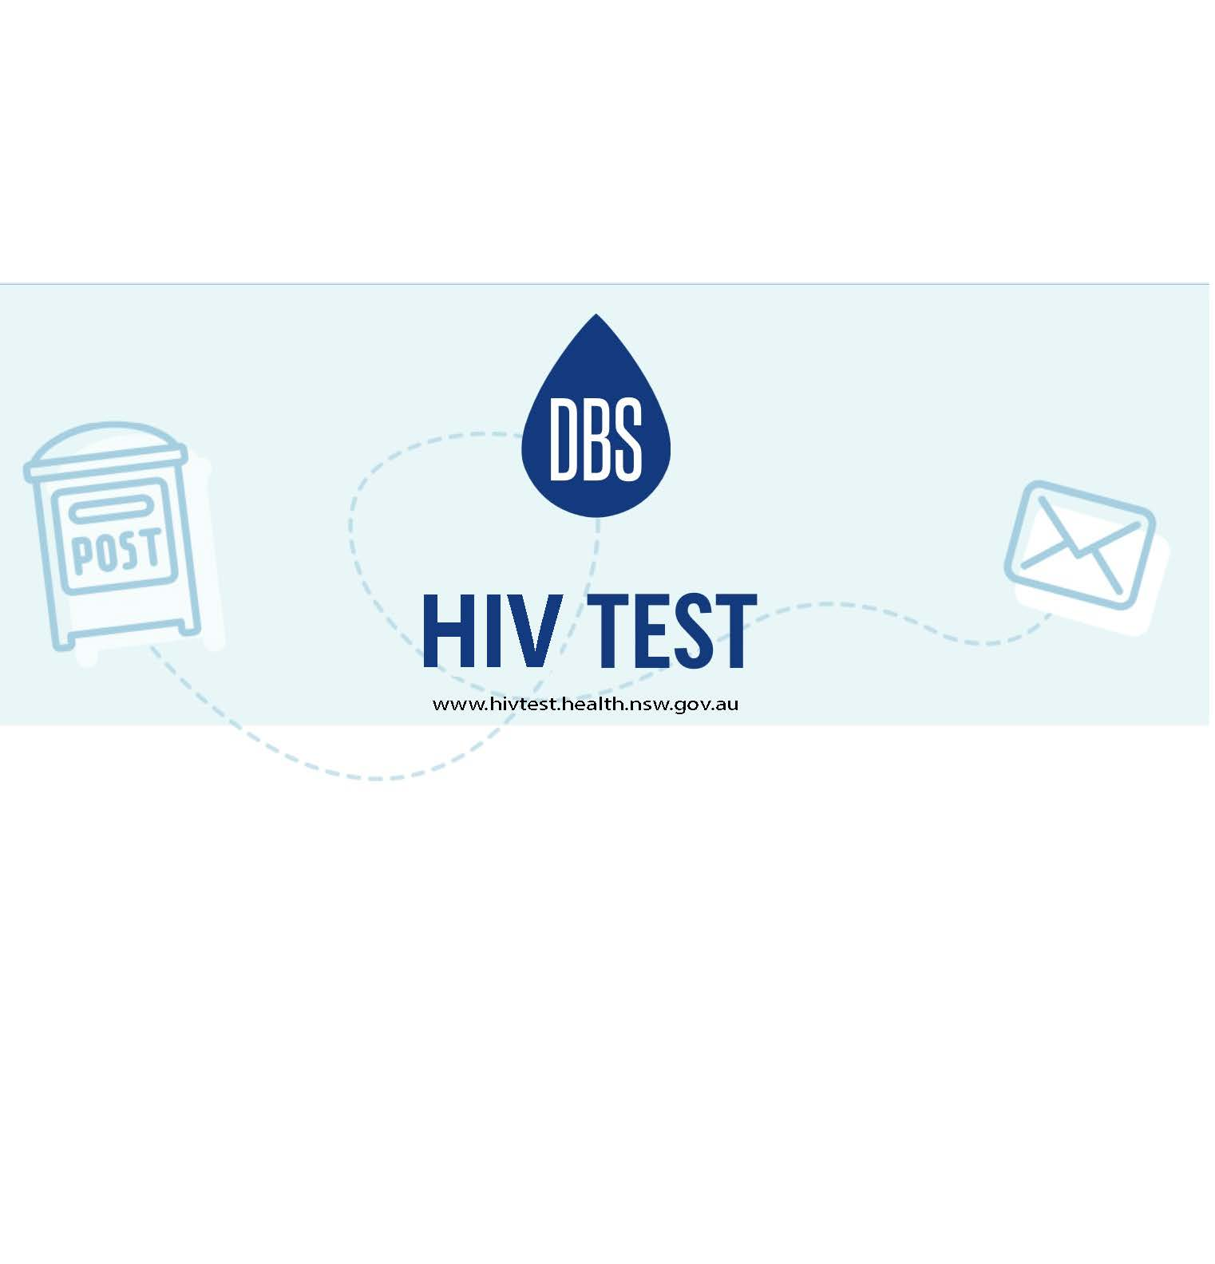
Manager of the Multicultural HIV and Hepatitis Service, Barbara Luisi, said improved treatment for HIV means those diagnosed early can live just as long as people who are HIV free.
“We have made great strides in HIV treatment, but until HIV is a thing of the past, there is more to do. We hope the launch of this home testing kit will encourage people at risk to find out their HIV status, so they can get the best care for themselves and their partners. We hope it will encourage men who have sex with men or people from African and Asian communities to seriously consider testing especially as they can now order a home testing kit free online.”
New HIV figures show an estimated 27,150 people in Australia are living with HIV in 2016, with around 3,350 (12%) unaware and at risk of unknowingly passing on the virus to others.
Men born in South East Asia make up 15 per cent of all diagnosis among men who have sex with men, and 44 per cent of new diagnoses are among men who have sex with men who were born overseas.
In addition, 42 per cent of people born in South East Asia and 38 per cent of people born in Sub-Saharan Africa were diagnosed at a late stage of infection, undermining the benefits of effective therapy and demonstrating the need for expanded testing.
HIV testing also benefits the community, according to Rosemary Kariuki-Fyfe of African Women’s Group in NSW.
“The benefits of testing extend beyond the individual person or family. Testing could also lead to early treatment which has wide public health benefits in reducing the risk of passing the virus on to other people,” said Ms Kariuki-Fyfe.
“HIV testing is key to prevention. I hope our community will take the opportunity to get tested and help eliminate new HIV infections by 2020.”
HIV Home testing kit:
The HIV home testing kit DBS (Dried Blood Spot HIV Test) allows individuals to order a self-sampling kit online, take their own sample in the privacy of their own home and send it to a laboratory for testing and results management. You do not need to go to a clinic or doctor to do this test. Testing kits can be ordered from http://www.hivtest.health.nsw.gov.au which also has information in different languages including plain English.
2016 World AIDS Day and HIV Awareness Week campaign aims to increase awareness of the health benefits of early HIV testing and treatment. Stories about living with HIV and treatment could be heard at http://www.health.nsw.gov.au/endinghiv/Pages/HIV-testing.aspx
--- END ---
For media interviews in Thai, please contact Sonam Paljor on (02) 9515 1234.
About HIV
HIV is most commonly transmitted through unprotected sexual contact. Condoms are one of the most effective ways to prevent the transmission of HIV.
There is currently no cure or vaccine available for HIV/AIDS. However, there are effective treatments that can greatly slow the effect HIV has on the body and means that people with HIV can live long, healthy and productive lives.
For further information on free and anonymous HIV testing, please contact your local sexual health clinic listed under Sexual in the White Pages.
To contact a service using a telephone interpreter, call 131 450 from anywhere in Australia for the cost of a local call. Discussions through an interpreter are always confidential.
Some of the major sexual health clinics in Australia include:
- NSW: Sydney (02) 9382 7440 / Liverpool (02) 9827 8022
- VIC: Melbourne (03) 9347 0244
- SA: Adelaide (08) 8226 6025
- QLD: Brisbane (07) 3227 8666

