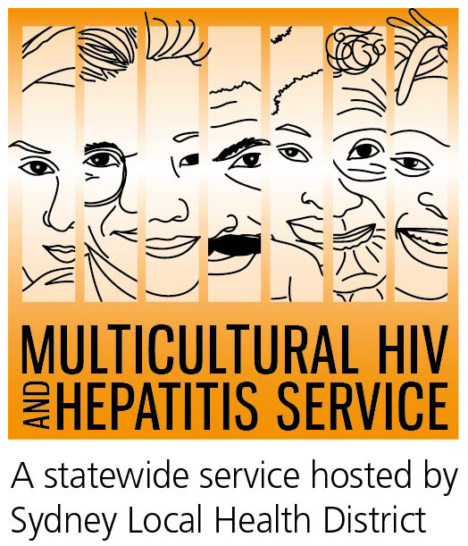
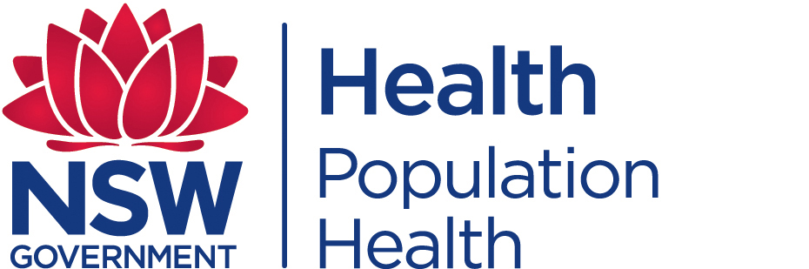
Media Release
31st of May 2016
HIV campaign promotes testing among diverse communities
This HIV Testing Week (1-7 June), people including those from culturally diverse backgrounds are being urged to get tested for HIV.
The campaign, an initiative of the NSW Ministry of Health, aims to raise awareness of the importance of HIV testing and reduce HIV transmission.
Manager of the Multicultural HIV and Hepatitis Service (MHAHS), Ms Barbara Luisi, said the campaign encourages gay and homosexually active men to get tested for HIV. It also asks people from a country with high rates of HIV and those who have had unprotected sex with a person from a high risk country to get tested.
"About 12 per cent of people with HIV in Australia are unaware they have the virus. About 30 per cent of new diagnoses among people from culturally diverse backgrounds in 2014 were diagnosed late. As well as unknowingly passing the virus onto others, people with late diagnoses also suffer poorer health compared to those diagnosed on time,” said Ms Luisi.
There are many benefits to being diagnosed with HIV early, according to Associate Professor David Templeton, Senior Specialist at the RPA Sexual Health, Sydney Local Health District.
“It's important to get tested for HIV early because, although you might feel healthy, the infection can still damage your health. The sooner you are diagnosed, the earlier you can access treatment, so you can lead a full and healthy life,” said Dr Templeton.
Bringing about a change in community perceptions about HIV and it’s testing, however, remains a work in progress, according to the Wa’el Sabri, Senior Community Development Officer at the MHAHS.
"HIV/AIDS awareness is low in many culturally diverse communities, including our African communities. The stigma attached to HIV means it’s difficult to talk about and causes anxiety about testing. As well as the fear of being diagnosed HIV positive, people worry about confidentiality,” said Mr Sabri.
Getting a HIV test is now easier and faster than ever before. A mix of high quality, safe and innovative HIV testing services such as rapid HIV testing, express clinics, after hours and drop- in clinics, faster results and online bookings are all part of the new era in HIV testing in NSW. Soon, HIV home testing kits can be ordered online. People can also request a test from their GP.
The multilingual Ending HIV equation of the campaign promotes three steps to eliminate the spread of HIV by 2020:
Test More - more of us need to get tested more often, as this is the only way that infections can be diagnosed and access to treatment can be increased. How often depends on a person’s lifestyle and sexual behaviour.
Free and anonymous HIV tests are available at sexual health clinics located across Australia. At sexual health clinics you do not need to have a Medicare card or give your real name.
Treat Early - advances in HIV medicines offer improved health benefits for people with HIV and can reduce traces of the virus in their body to an undetectable level. This significantly reduces the likelihood of transmitting HIV.
Stay Safe - condoms and other risk reduction strategies remain central to the fight against HIV so people need to maintain a culture of safe sex
HIV is most commonly transmitted through unprotected sexual contact. Condoms are one of the most effective ways to prevent the transmission of HIV.
There is currently no cure or vaccine available for HIV/AIDS, but there are effective treatments that can greatly slow the effect HIV causes to the body.
For further information on free and anonymous HIV testing, please contact your local sexual health clinic, listed under Sexual in the White Pages. To contact a service using a telephone interpreter, call 131 450 from anywhere in Australia for the cost of a local call. Discussions through an interpreter are always confidential.
Some of the major sexual health clinics In Australia include:
NSW: Sydney (02) 9382 7440 | Liverpool (02) 9827 8022 | | Melbourne (03) 9341 6200 |
Brisbane (07) 3837 5611 | Adelaide (08) 8226 6025 | Perth (08) 9224 2178 | Hobart (03) 6166 0990
--- END ---
For media interviews, please call Sonam on 9515 1241.
About HIV/AIDS
AIDS is a disease caused by a virus known as HIV and affects men, women and children from all cultures, countries and religions.
According to the Joint United Nations’ Program on HIV/AIDS (UNAIDS), there were an estimated 36 million people living with HIV at the end of 2014. In Australia, there were more than 27 thousand people living with diagnosed HIV infection in 2014.
About the MHAHS (Multicultural HIV and Hepatitis Service)
The Multicultural HIV and Hepatitis Service, hosted by the Sydney Local Health District, employs workers from more than 20 language backgrounds, including Asian and African languages, who provide support to people affected by HIV in NSW. The workers are bound by strict laws protecting the privacy of the people they support. The service is free and no identification of any kind is needed. It can be reached on (02) 9515 1234

