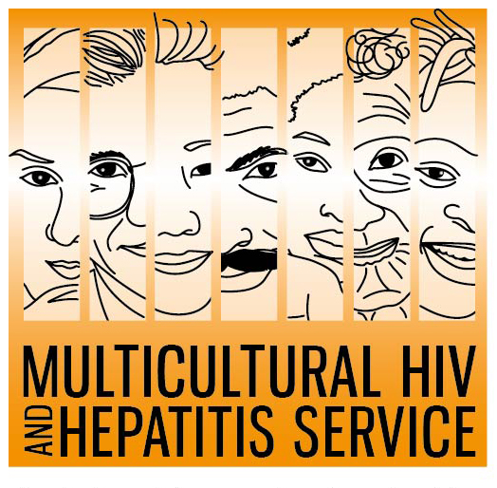
Media Release
24 May 2018
7 Good Reasons to support
NSW HIV Testing Week
An exciting new multi-lingualresource 7 Good Reasons to Get Tested for HIV Now is set to be launched during this year’s HIV Testing Week starting June 1st. Produced by the MHAHS and Positive Life NSW, this new easy to read resource features a everyday people using every day language to explain the many benefits of regular HIV testing.
The resource directly complements this year’s campaign theme “Never Tested for HIV? Get Tested Today’, according to Barbara Luisi, Manager of the MHAHS.
“There are many reasons to get tested for HIV. Nearly one in ten Australians remain unaware of their HIV status, don’t get HIV medical care on time and can pass the virus on to others without knowing it. Taking the test is the only way to know for sure. The new ‘7 Good Reasons to test’ provides people the simple, easy to understand information they need regarding HIV testing”, said Ms Luisi.
Funded by the NSW Health, the resource is available online at www.mhahs.org.au in Arabic, Chinese, Indonesian, Portuguese, Spanish, Thai and Vietnamese.
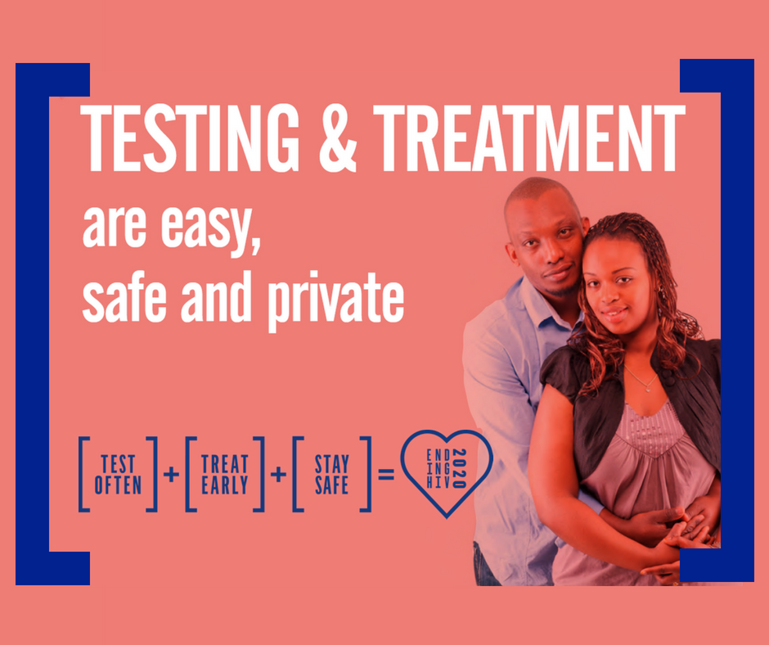
HIV remains a public health concern with an estimated 26,444 people living with HIV in Australia in 2016. Nearly one in ten Australians newly diagnosed with HIV speak a language other than English at home these past ten years.
Craig Cooper, Chief Executive Officer of Positive Life NSW said “people from diverse backgrounds continue to face barriers to appropriate HIV prevention, testing and treatment.”
“Raising awareness of HIV among CALD communities to achieve higher levels of testing and treatment is essential if we are to achieve our ambitious target of ending HIV transmission by 2020,” said Mr Cooper.
The convenience of getting a HIV test is another reason why people should get tested for HIV, said Ms Luisi.
“It is easy to get tested for HIV, with many options available today. HIV tests are confidential. Now they are also easier and quicker with people at higher-risk of HIV across NSW now able to order a free home testing kit online for convenience.”
The HIV home testing kit, Dried Blood Spot HIV Test (DBS) allows individuals to order a free self-sampling kit online, take their own sample in the privacy of their own home and send it to a laboratory for testing and results management. You do not need to go to a clinic or doctor to do this test. Testing kits can be ordered from http://www.hivtest.health.nsw.gov.au which also has information in a range of languages including plain English.
The MHAHS is undertaking several initiatives during HIV Testing Week including an ethnic media campaign in eight languages, a series of Facebook messages and a free HIV Testing Week Toolkit containing all the digital assets for other organisations to use.
-END
For media interviews, please contact Sonam Paljor on 02-95151234 www.mhahs.org.au www.facebook.com/TheMHAHS

