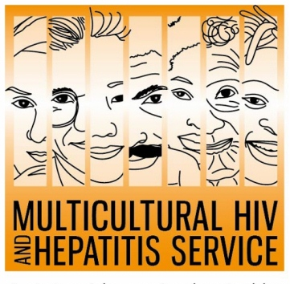
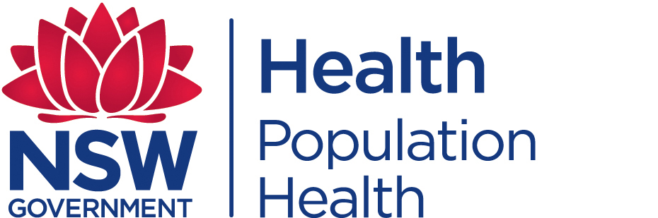
Media Release
1 December 2018
Know your HIV status: World AIDS Day
This year’s World AIDS Day is encouraging everyone to know their HIV status. Aimed at increasing awareness of HIV in the world, the “Know your status” theme marks the World AIDSDay’s 30th anniversary on 1 December.

Significant progress has been made since the first World AIDS Day campaign in the 1980s, according to Barbara Luisi, Director of the Diversity Programs and Strategy Hub of Sydney Local Health District.

“Today, three in four people living with HIV in the world know their status. But much remains to be done, the latest national Kirby HIV report shows that 1 in 10 people living with HIV in Australia don’t know they have it, so are not linked to quality care and prevention services,” said Ms Luisi.

To mark the occasion and improve HIV testing rates, the MHAHS is relaunching its popular "7 Good Reasons to test" resource. Produced in partnership with the Positive Life NSW, this easy-to-read resource features everyday people using everyday language to explain the many benefits of regular HIV testing.

Regular HIV testing is essential in identifying people with HIV as early as possible, according to Professor David Templeton, Acting Director of Sydney Local Health District Sexual Health Service .

“HIV testing is critical to ensure that all people living with HIV can be identified as early as possible and made aware of their diagnosis. The highly effective treatments available currently mean people living with HIV can lead healthy, productive and long lives. HIV treatments usually lead to a very low amount of HIV virus detected in the blood, which makes it highly unlikely a person with HIV can pass on the infection to others,” said Professor Templeton.

Unfortunately, many barriers to HIV testing remain. HIV awareness is still low, particularly among people from culturally diverse communities. Stigma and discrimination still deters people from taking an HIV test. As well as the fear of being diagnosed HIV positive, people also worry about confidentiality, which can stop people from testing at all, particularly those from communities where there are very high levels of HIV-related stigma and discrimination. Many people still only get tested after becoming ill from HIV.

“The good news is that there are many safe and innovative new ways of getting HIV test. Testing at home by ordering a dried blood spot test kit has been available from the past year. Fast-track “Express” clinics, after hours appointments, and peer-led community-based testing clinics for men who have sex with menare all part of the new era in HIV testing in NSW. People can also request a test at their GP. HIV testing is easy, safe and confidential,” said Professor Templeton.

Join MHAHS this World AIDS Day in raising awareness about the importance of knowing one’s HIV status and calling for the removal of all barriers to accessing HIV testing.

The Sydney Local Health District based MHAHS is undertaking several initiatives during the World AIDS Day campaign. As well as implementing an ethnic media campaign across six languages, it is partnering with Pozhet in promoting a 15-sec video on safe sex and HIV testing aimed at heterosexuals travelling overseas.
HIV is most commonly transmitted through unprotected sexual contact. Condoms still remain an important way of preventing the transmission of HIV, as well as many other sexually transmitted infections.

There is currently no cure or vaccine available for HIV/AIDS, but there are effective treatments that can greatly slow, and even reverse, the damage HIV causes to the body.For further information on free and anonymous HIV testing, please contact your local sexual health clinic, listed under Sexual in the White Pages. To contact a service using a telephone interpreter, call 131 450 from anywhere in Australia for the cost of a local call. Discussions through an interpreter are always confidential.

Some of the major sexual health clinics In Australia include:
NSW: RPA (02) 9515 1200 / Sydney (02) 9382 7440 / Liverpool (02) 9827 8022
VIC: Melbourne (03) 9347 0244
SA: Adelaide (08) 8226 6025
QLD: Brisbane (07) 3227 8666

--- END ---

For media interviews, please call 9515 1241.

