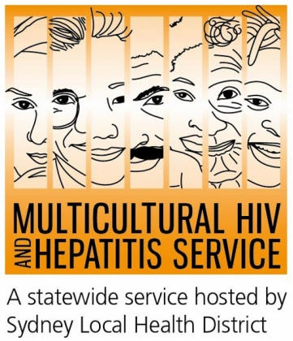
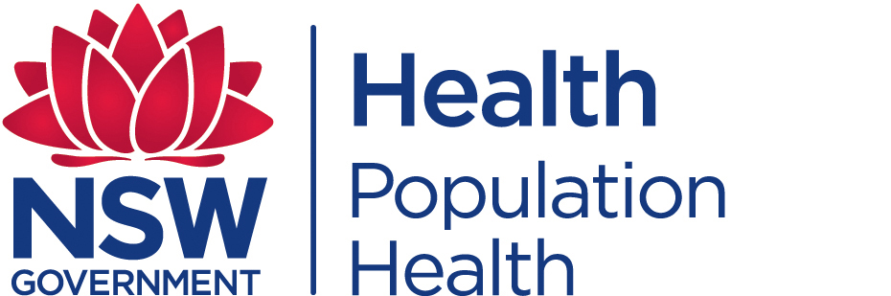
Media Release
27th November 2019
Every Journey Counts: 2019 World AIDS Day Campaign
This World AIDS Day campaign is urging wider community engagement to tackle HIV. The #EveryJourneyCounts campaign acknowledges the diversity of people affected by HIV and encourages people living with HIV to participate fully in community life.
The campaign acknowledges that World AIDS Day means different things to different people, according to Barbara Luisi, Director of the Diversity Programs and Strategy Hub of Sydney Local Health District.
“For some, World AIDS Day is a time to remember and reflect on the past and a time to show their support for people living with HIV. For others, it is an opportunity to celebrate the strength and diversity of all communities affected by HIV and stand with them in solidarity and remembrance.”
There were more than 37 million people worldwide living with HIV in 2018 with more than 27,000 Australians estimated to be living with HIV in 2017. Fourteen percent of all people newly diagnosed with HIV spoke a language other than English at home and 1 in 10 Australians living with HIV don’t know they’ve the virus.

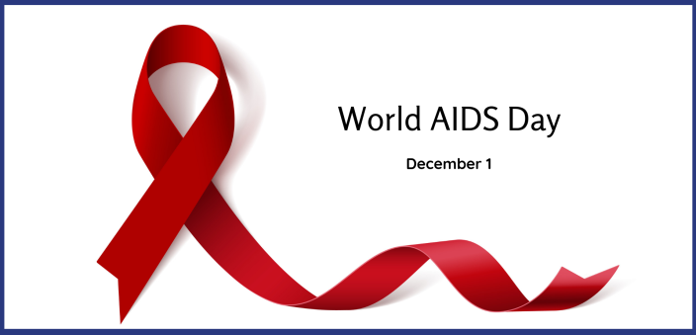
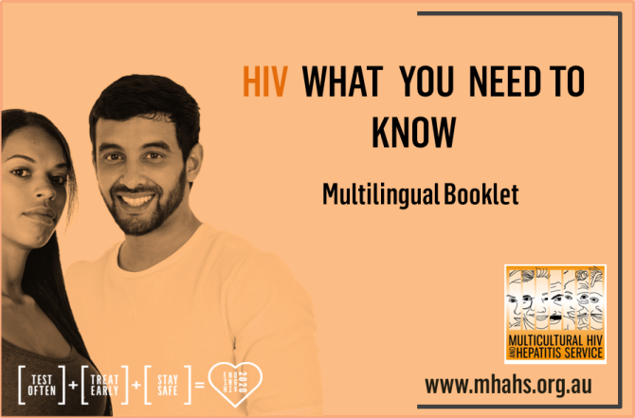
The Multicultural HIV and Hepatitis Service (MHAHS) is supporting World AIDS Day with limited release of a new multilingual resource HIV. What you need to know. Developed in consultation with the Arabic, Chinese, English, Indonesian, Portuguese, Spanish, Thai and Vietnamese communities, the new booklet provides the most up-to-date information to connect community members with HIV prevention, testing and treatment services in NSW. You can download or order the resource, ahead of a full scale launch in the New Year, at www.mhahs.org.au.
World AIDS Day is an amazing opportunity to commit to a future free of HIV, according to Dr Fiona Fargie, Staff Specialist at RPA Sexual Health in Sydney Local Health District.
“World AIDS Day encourages people to come together against HIV, by learning how to protect themselves and others from HIV and knowing where to get tested for HIV and receive treatment,” Dr Fargie said.

HIV is most commonly transmitted through unprotected sexual contact. Condoms still remain an important way of preventing the transmission of HIV along with new interventions such as PrEP.

You can participate in World AIDS Day on December 1 by wearing a red ribbon, the symbol of solidarity for people living with HIV. Australian World AIDS Day activities can be viewed on www.worldaidsday.org.au.

Some of the major sexual health clinics In Australia include:

NSW: RPA (02) 9515 1200 / Sydney (02) 9382 7440 / Liverpool (02) 9827 8022

VIC: Melbourne (03) 9347 0244

SA: Adelaide (08) 8226 6025

QLD: Brisbane (07) 3227 8666

--- END ---

For media inquiries, please call 9515 1234 or email info@mhahs.org.au.

