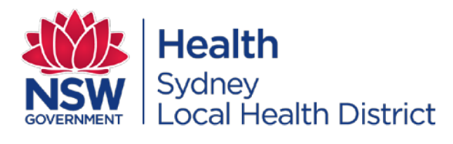
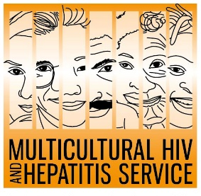
Media Release
1st June 2020
HIV testing still important during COVID-19 outbreak: HIV Testing Week
This HIV Testing Week is calling for people to know their HIV status despite the ongoing COVID-19 pandemic. Aimed at helping people find out their HIV status, the campaign urges people including those from diverse cultural backgrounds, to get tested for HIV.
HIV testing is a vital first step to tackling HIV, according to Barbara Luisi, Director of the Diversity Programs and Strategy Hub at Sydney Local Health District.
“HIV testing can put people in control of their HIV status. Where a test is positive, effective treatments mean people can live a long, healthy life and are less likely to pass on the virus. Regardless of the test result, testing also helps make people HIV aware, giving them the facts and confidence to prevent new infections, and ultimately putting an end to HIV,” said Ms Luisi.
HIV remains a public health concern in Australia with an estimated 27, 545 people living with HIV in Australia currently.
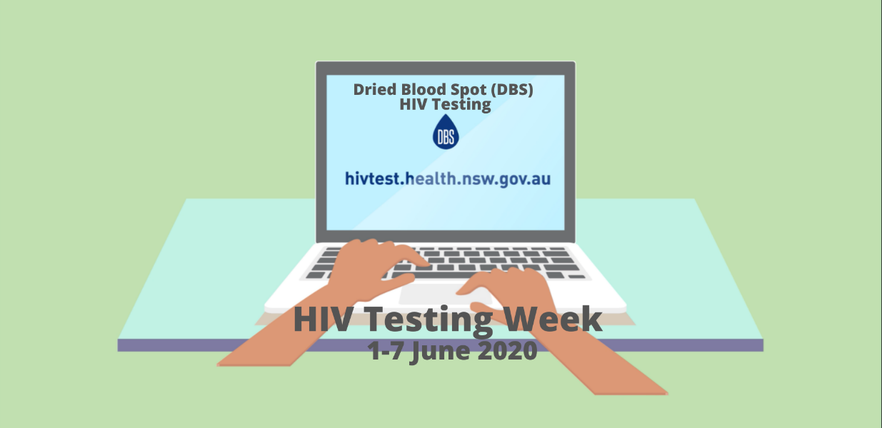
Nearly one in ten Australians living with HIV are unaware they have the virus and may be unknowingly passing on the virus to others. They also risk missing out on getting HIV treatments on time due to late diagnosis.
The Testing Week campaign aims to increase awareness of HIV testing and encourages people to test regularly.
There are a variety of ways to get tested for HIV, according to Professor David Templeton, Head of Department, Sexual Health Medicine at the RPA Sexual Health of the Sydney Local Health District.
“It is easy to get tested for HIV, especially as people across NSW can now order a free home testing kit online.”
The HIV home testing kit, Dried Blood Spot (DBS) HIV Test allows people to order a free self-sampling kit online, take their sample in the privacy of their own home and send it to a laboratory for testing and results management. You do not need to go to a clinic or doctor to do this test. Testing kits can be ordered from http://www.hivtest.health.nsw.gov.au which also has information in a range of languages including plain English.
The DBS test results are kept private and confidential.
The Sydney Local Health District based Multicultural HIV and Hepatitis Service is supporting the campaign by undertaking an ethnic media campaign across eight languages to promote home HIV testing.
For media interviews, please contact Sonam Paljor at 9515 1234 or email sonam.paljor@health.nsw.gov.au

