
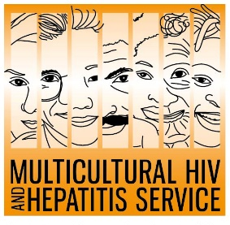
District aims to reduce stigma about HIV
1 December 2021
District marks World AIDS Day as booklet about living with HIV recognised
A multilingual HIV information booklet developed by Sydney Local Health District has been recognised as a finalist in the 2021 Multicultural Health Communication Awards, as the world marks 40 years since the start of the AIDS epidemic.
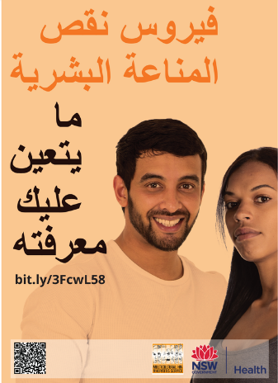
The state-wide Multicultural HIV and Hepatitis Service, hosted by the District, partnered with the community to develop the booklet, called HIV – What you need to know. It focuses on HIV prevention, testing, and treatment as well as addressing stigma and improving access to health services.
“Advances in treatments and prevention mean that people with HIV on effective treatments can enjoy long and healthy lives, have virtually no risk of passing on HIV to others and can have children without HIV,” Barbara Luisi, the District’s Director of the Diversity Programs and Strategy Hub, said.
The Multicultural HIV and Hepatitis Service works with people living with HIV from diverse communities, many of whom report feeling isolated and stigmatised within the general community.
“In response to the concerns of our community, we developed this booklet in partnership with them. Insights and feedback from community consultations, focus group testing and peer-review played a critical role in taking a culturally appropriate approach to a sensitive topic,” Ms Luisi said.
The booklet is available in eight languages – English, Arabic, Chinese, Indonesian, Portuguese, Spanish, Thai and Vietnamese.
So far, more than 6,500 hard copies have been distributed state-wide through healthcare services, NGOs and community based organisations. Digital copies can be downloaded from the Multicultural HIV and Hepatitis Service.
“We hope it will contribute to changing attitudes about HIV and help to reduce stigma,” Ms Luisi said.
The recognition as a finalist in the Multicultural Health Communication Awards coincides with World AIDS Day, which is an opportunity to reflect on the response to the HIV and AIDS epidemic. This year’s theme is 40 years of HIV – where to next?
The first five cases of what later became known as AIDS were officially reported in 1981.
It marked the beginning of a devastating public health crisis, but in the decade since there have been scientific advances particularly in the area of HIV treatments and prevention.
The NSW HIV Strategy 2020 – 2025 continues Australia’s commitment to end HIV by 2025 while acknowledging that stigma continues to create barriers to HIV testing and treatment.
The Strategy aims for a 75 per cent reduction in discriminatory attitudes held towards people living with or at risk of HIV.
The winners of the Multicultural Health Communication Awards will be announced on 8 -December 2021. [ENDS]
For media interviews in Arabic, please contact Sonam Paljor on 0436 649 000 or email Sonam.paljor@health.nsw.gov.au

