June 2022

Routine testing key to eliminating HIV: 2022 HIV Testing Week

This year’s HIV Testing Week (1-7 June) is reminding people, including those from diverse backgrounds, to resume routine HIV testing.

Early diagnosis helps people get effective HIV treatments in time and reduces the risk of passing on HIV to others.

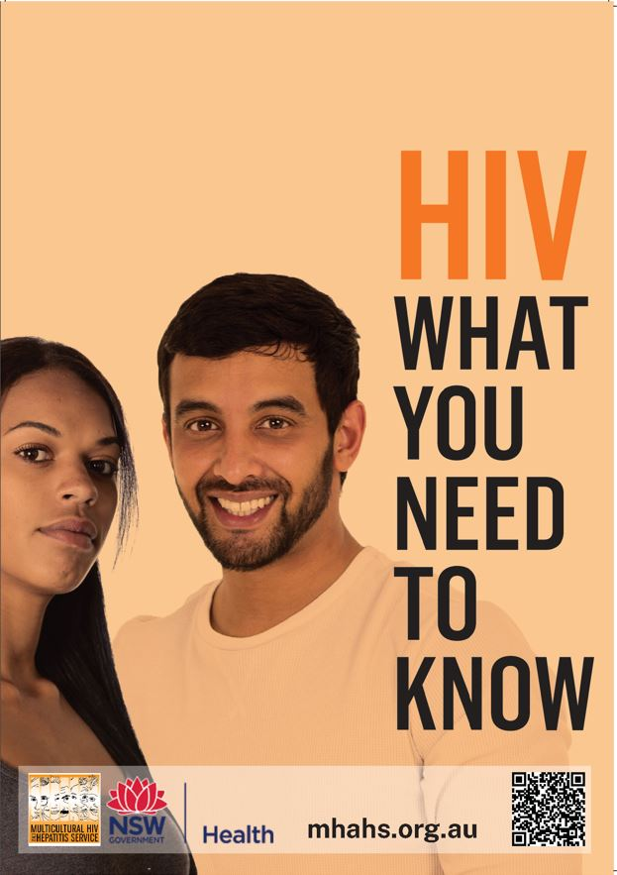
Data released by NSW Health shows HIV testing rates dropped in 2021 due to COVID-19 disruptions.

“Now that we are getting out of pandemic lockdowns, it is important that people at risk of HIV return to their routine, regular HIV testing habits” said Professor David Templeton, Head of Sexual Health Medicine at Sydney Local Health District, based at RPA Sexual Health.

“In Australia, we are on the cusp of eliminating HIV transmission thanks to our success in diagnosing and treating HIV early, which reduces HIV transmission to close to zero. In addition, we have high numbers of people at risk of HIV taking HIV pre-exposure prophylaxis or PrEP. Just one pill a day prevents them from catching HIV. However, certain populations in our community such as recent overseas arrivals and people from culturally and linguistically diverse backgrounds are missing out. Regular testing for HIV is crucial to reaching our goal of ending HIV by 2030,” said Prof Templeton.

There are many options to get a HIV test. HIV testing is free if you have a Medicare card. If you are a temporary visitor in NSW and don’t have a Medicare card, Sexual Health Clinics offer free, easy and confidential services. For people wanting to avoid crowded places such as doctor’s offices and clinics, the online DBS test remain a popular option.

“Dried Blood Spot testing is an easy way for you to get tested for HIV,” said Barbara Luisi, the District’s Director of the Diversity Programs and Strategy Hub. “You can order a free DBS HIV testing kit online, do the test and send it to a laboratory for results. The test results are private and confidential.”

Your can order your DBS testing kit from hivtest.health.nsw.gov.au. For more information on HIV testing, treatment and prevention, download HIV – What you need to know resource from mhahs.org.au/index.php/en/hiv/hiv-what-you-need-to-know

For media interviews in language, please contact Sonam Paljor at 9515 1234 or email sonam.paljor@health.nsw.gov.au

