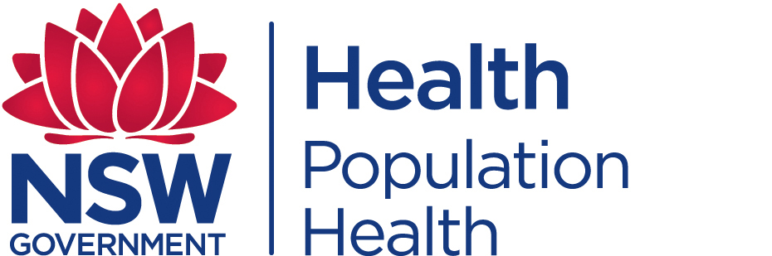
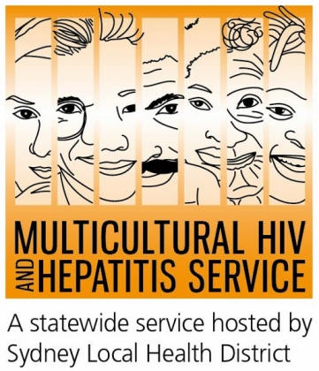
Media Release
19 March 2015
2015 WORLD TB DAY campaign
ROUNDTABLE HIV DISCUSSION COMPLEMENTS WORLD TB DAY CAMPAIGN
A roundtable discussion to raise awareness and engagement in HIV care for people from culturally and linguistically diverse (CALD) backgrounds was held on 17th March at Cabra-Vale Diggers Club in south western Sydney.
Organised by the Multicultural HIV and Hepatitis Service (MHAHS) of the Sydney Local Health District (SLHD) in partnership with South West Sydney Local Health District (SWSLHD), the forum themed Ending HIV: ensuring CALD communities are not left behind, was aimed at improving the health outcomes for people from CALD backgrounds living with HIV.
The emphasis on making HIV care more inclusive and leaving no one behind including people from CALD backgrounds directly complements the 2015 World TB Day Campaign, according to Barbara Luisi, manager of the MHAHS.
“Tuberculosis is often one of the first opportunistic infections experienced by those who don’t know they have HIV. The global campaign calls on the world to leave no one with TB behind and asks that all people – regardless of their age, gender, race, language or other status – be included in this process of testing, treating and caring for people with TB,” said Ms Luisi.
The MHAHS runs a number of HIV related campaigns throughout the year aimed at people from CALD backgrounds, including people residing in the SLHD.
The World Health Organisation (WHO) estimates that a third of the 9 million new cases of tuberculosis (TB) each year are not picked up by the health care system. About one million of these people are also living with HIV.
Ms Luisi, says people from CALD backgrounds continue to be affected by HIV often with poor health outcomes.
“This roundtable was about understanding issues for people from CALD backgrounds and identifying how agencies can work better with them to prevent, treat and care for their HIV needs. Our goal is to develop a system response towards a vulnerable population and ensure they are not left behind,” she said.
People living with HIV (PLHIV) have more than a 20-fold increased risk of TB compared to HIV uninfected people.
Australia has one of the lowest TB rates in the world, largely due to its effective migration screening program and specialised health services dedicated to the prevention and control of TB. Despite this, people living in Australia who were born in countries where TB is common may be at an increased risk of developing TB disease.
“It is important that we acknowledge diversity and provide culturally-appropriate information to address HIV and TB stigma and misunderstanding,” according to Chris Lowbridge, manager of the NSW TB Program.
“People born overseas who develop symptoms of TB may not know where to seek help or advice. Our public need to know that TB is curable and that TB services, located around Australia, provide free and confidential testing, treatment and care,” said Dr Lowbridge.
The WHO recommends that people found to have TB are tested for HIV and vice versa.
Information on tuberculosis and where to find chest clinics in NSW is available in various languages at http://www.health.nsw.gov.au/Infectious/tuberculosis/Pages/default.aspx and information on HIV and sexual health clinics in NSW is available in various languages at www.mhahs.org.au.
###
For media enquiries call Sonam on 9515 1241

