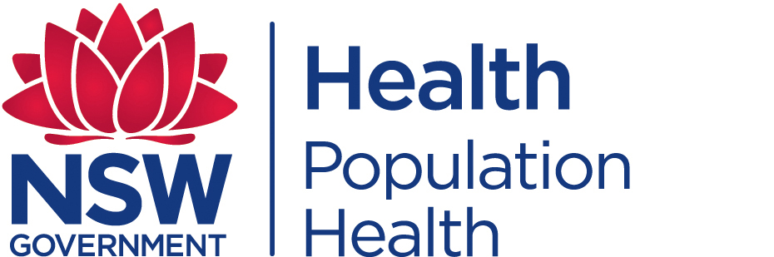
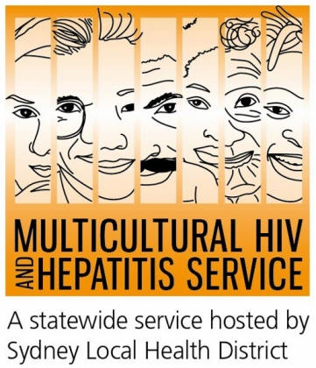
Media Release
24 March 2016
#UnitetoEnd TB: 2016 WORLD TB DAY
We can end tuberculosis (TB) in our lifetime if we work more closely with all sectors of society, including marginalised populations, according to this year’s World TB Day. Aimed at increasing awareness of TB in the world, the March 24 global campaign calls for active partnerships in increasing health care access for vulnerable populations.
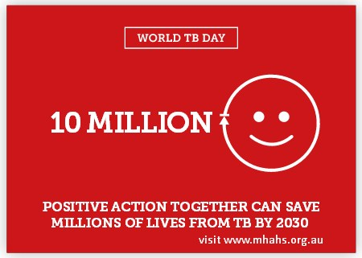
Reaching marginalised populations is a must for ending TB, according to Barbara Luisi, manager of the Multicultural HIV and Hepatitis Service (MHAHS).
“It is imperative that we strive to protect marginalised groups, provide them with care, and involve them as active partners in the fight against the disease,” said Ms Luisi.
“Tackling TB has direct benefits for global HIV efforts as well. TB is often one of the first opportunistic infections experienced by those who don’t know they have HIV. As such, improving diagnosis, treatment, and outcomes for TB patients from vulnerable groups will also improve the outcome for people living with HIV,” said Ms Luisi.
The World Health Organisation (WHO) estimates that a third of the 9 million new cases of tuberculosis (TB) each year are not picked up by the health care system. About one million of these people are also living with HIV.
People living with HIV (PLHIV) have more than a 20-fold increased risk of TB compared to HIV uninfected people.
Australia has one of the lowest TB rates in the world, largely due to its effective migration screening program and specialised health services dedicated to the prevention and control of TB. Despite this, some migrants to Australia still remain vulnerable to TB.
Migrants from areas which have higher rates of TB, such South East Asia, may be at increased risk of developing TB, particularly in the years shortly after arrival in Australia. Globally, TB is often associated with poor living conditions, but anyone who has lived or worked in countries with high rates of TB may be at risk of developing TB in the future.
“People born overseas who develop symptoms of TB may not know where to seek help or advice. Our communities need to know that TB is curable and that TB services across Australia provide free and confidential testing, treatment and care for anyone in the community with TB symptoms; including those who do not have access to Medicare said Dr Vicky Sheppeard, Director Communicable Diseases Branch, NSW Health.
The WHO and NSW Health recommend that people found to have TB are tested for HIV and people with HIV are tested for TB infection.
Information on tuberculosis and where to find chest clinics in NSW is available in various languages at http://www.health.nsw.gov.au/Infectious/tuberculosis/Pages/default.aspx and information on HIV and sexual health clinics in NSW is available in various languages at www.mhahs.org.au.
###
For media enquiries call Sonam on 9515 1241

